
TwitterVane

Installation
Guide

04 February 2013
Contents


Introduction 3
Contents of this document 3
Getting Started 4
Prerequisites 4
Supported platforms 4
Other platforms 4
Setting up the database 5
Setup using PostgresQL 8.2 5
Application Server Setup 6
Overview 6
Recommended Deployment Configuration 6
Deploying TwitterVane to Tomcat 6
Configure the Application Context 7
Configure the RMI Connection 7
Configure Logging 8
Start the Application Servers 8
Troubleshooting setup 11

Introduction

This guide covers installation, setup and deployment of TwitterVane.

Contents of this document
Following this introduction, the Guide includes the following sections:
- Getting Started (page 4) — covers prerequisites, supported platforms, other platforms, and optional prerequisites for using the Web Curator Tool
- Setting up the database (page 5)— procedures for setup using PostgreSQL 8.2
- Error: Reference source not found Setup (page Error: Reference source not found) — procedures for deploying TwitterVane to Tomcat, includes configuration options and troubleshooting

Getting Started

The following section explains how to get TwitterVane up and running.

Prerequisites

The following are required to successfully install and run TwitterVane:
- Java 1.6 JDK or above
- Apache Tomcat 6.X or above (the application has been tested on Tomcat 6.0.35)
- A Postgresql 8.2 database server.

Supported platforms
The following platforms have been used during the development of the TwitterVane:
- Red Hat Linux EL3.

Other platforms
The following platform was used during the Development of the Web Curator tool but is not explicitly supported:
- Windows XP.

Setting up the database

Setup using PostgresQL 8.2
This guide assumes you have installed and configured Postgresql 8.2 prior to setting up the TwitterVane database and schema.

- Create the database and role:

CREATE DATABASE "twittervane" WITH ENCODING='UTF8';
\c twittervane
CREATE ROLE usr_tv LOGIN PASSWORD 'password' NOINHERIT VALID UNTIL 'infinity';
grant all PRIVILEGES on DATABASE twittervane to usr_tv;

- Generate the database schema:

Run the following script using the Postgres SQL command line, psql:

psql –f twittervane –f /twittervane/TweetView/sql/schema.sql

- The Postgres JDBC driver is included in the GitHub repository under the /TweetView/lib/ directory.
- The Postgres driver is called postgresql-8.2-507.jdbc4.jar
- The driver will need to be placed into the $TOMCAT_HOME/common/lib/ directory.
- Also required in the $TOMCAT_HOME/common/lib/ directory is the jta.jar

Application Server Setup

Overview
There are three major components to the deployment of the TwitterVane:
- the TweetView component (TweetView.war)
- the TwitterStreamAgent component (TweetStreamAgent.war)
- the TweetAnalyser component (TweetAnalyser.war).

Each of these three components must be deployed for TwitterVane to be fully functional.

The TweetView component provides the management and reporting features that curators use to create and report on Web Collections.

The TweetStreamAgent provides the UI and services for managing the inbound Tweet data from Twitter.

The TweetAnalyser performs URL expansion on shortened URLs associated with a Tweet, resolves a Tweet to a web collection, and manages the storage of Tweets.

All three components can be deployed to different Tomcat instances on a single server or distributed servers.

Recommended Deployment Configuration
The recommended deployment configuration for TwitterVane consists of using a separate Tomcat instance for each of the three components TweetView, TweetStreamAgent and TweetAnalyser.
This isolates application server resources for each component and balances system resources across all components. This means that when one component experiences high load, the other components are not adversely affected.

This also enables the required security constraints to be applied to each component. For example, the TweetStreamAgent and TweetAnalyser management UIs may need to be secured for administrator access only.

Deploying TwitterVane to Tomcat

To deploy TwitterVane to Tomcat:
- Make sure you have installed and configured both Java 1.6 JDK and Apache-Tomcat 6.X successfully.

- Deploy the WAR files into Tomcat. The simplest deployment is to deploy all three WAR files into the same Tomcat container.
- You can copy the WAR files into the $TOMCAT_HOME/webapps/ directory.
- Provided Tomcat is configured correctly, when you start Tomcat the WAR files will be exploded and the application will start.

- Shut down Tomcat once the WAR files have been extracted. This will allow you to modify the configuration files in the following steps.

Configure the Application Context
The curator user interface for TwitterVane is provided by the TweetView component. To allow curators to access TweetView via the URL:

http://servername:port/TwitterVane/

the application context for TweetView must be configured.
Edit the server.xml file in $TOMCAT_HOME/conf and add the following docBase and path properties within the <Host …> element:
<?xml version="1.0" encoding="UTF-8"?>
<Host appBase=”webapps” … >
<Context
docBase="/path/to/tomcat/home/webapps/TweetView" path="/twittervane" reloadable="true" >
</Context>
</Host>

Configure the RMI Connection
The TweetStreamAgent communicates with the TweetAnalyser via Spring RMI and acts as a client. The client connection is configured in the following file:
$TOMCAT_HOME\webapps\TweetStreamAgent\WEB-INF\spring-servlet.xml

<property name="serviceUrl" value="rmi://localhost:1199/TweetAnalyserService"/>

Ensure that the hostname value is correct for the “serviceUrl” property.

The serviceURL is defined by the RMI registry port which is created by the TweetAnalyser. The port is configured in RmiServiceExporter bean in the following file:
$TOMCAT_HOME\webapps\TweetAgent\WEB-INF\spring-servlet.xml

<bean class="org.springframework.remoting.rmi.RmiServiceExporter">
<!-- does not necessarily have to be the same name as the bean to be exported -->
<property name="serviceName" value="TweetAnalyserService"/>
<property name="service" ref="tweetAnalyserService"/>
<property name="serviceInterface" value="uk.bl.wap.crowdsourcing.agent.TweetAnalyserService"/>
<!-- defaults to 1099 -->
<property name="registryPort" value="1199"/>
</bean>

Configure Logging
The log files for each of the TweetView, TweetStreamAgent and TweetAnalyser components are configured in the components \WEB-INF\classes\log4j.xml file.

This file controls the location of the log file and the required logging level (INFO, DEBUG, ERROR etc).

The TweetStreamAgent also writes the content of a Tweet in Json format to a daily Json logfile. The name and location of the Json logfile is configured by the JsonLogger bean in the file:

$TOMCAT_HOME\webapps\TweetStreamAgent\WEB-INF\spring-servlet.xml

<!-- logger to write json tweets to a specified file -->
<bean id="jsonLogger" class="uk.bl.wap.crowdsourcing.logger.JsonLogger" lazy-init="false">
<property name="fileName" value="json" />
<property name="filePath" value="/usr/share/tomcat6/logs/json/" />
<property name="fileExtension" value=".log." />
</bean>

Start the Application Servers
Once the components are configured and the application servers started, each components UI will be available at the following URIs:

TweetView:
http://[server]:[port]/TwitterVane/

eg: server=localhost, port=8100

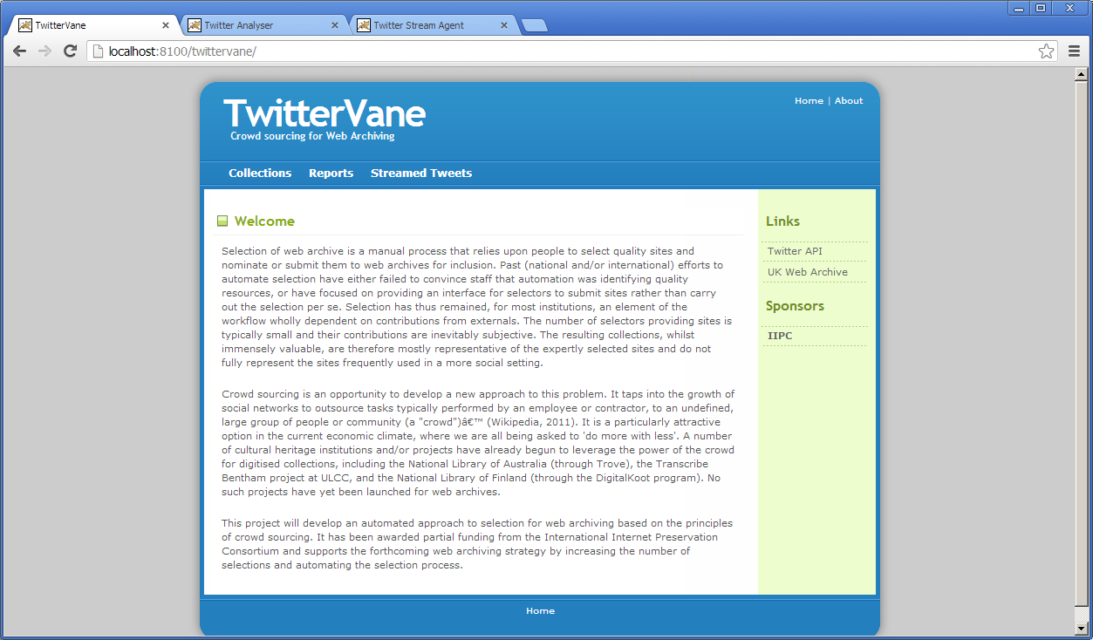

TweetAnalyser:
http://[server]:[port]/TweetAnalyser/

eg: server=localhost, port=8090

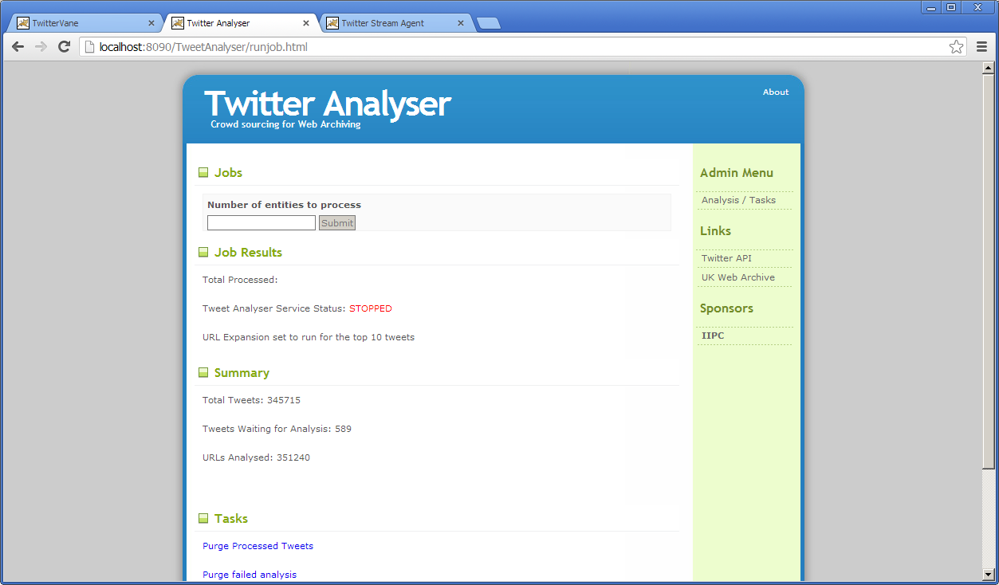

TweetStreamAgent:
http://[server]:[port]/TweetStreamAgent/

eg: server=localhost, port=8090

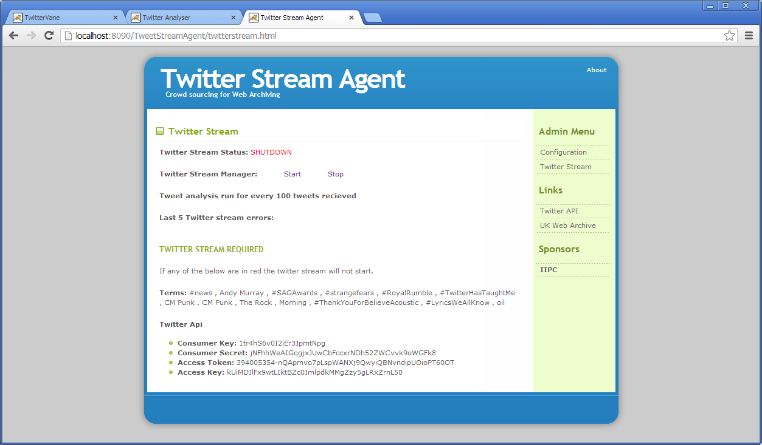

Troubleshooting setup
See the following table to troubleshoot TwitterVane setup.

Problem | Possible solution
Database connection failure | Check that the database connection is defined correctly in the WEB-INF\classes\META-INF\persistence.xml for all three components and that the server can communicate with this host on the specified port.
RMI exception on service start | The following exception can be thrown when the TweetStreamAgent and TweetAnalyser service are deployed within the same Tomcat instance:  2013-02-04 17:17:42,802 ERROR [main] servlet.FrameworkServlet (FrameworkServlet.java:466) - Context initialization failed  org.springframework.beans.factory.BeanCreationException: Error creating bean with name 'twitterStreamDaemonController' defined in ServletContext resource [/WEB-INF/spring-servlet.xml]: Cannot resolve reference to bean 'tweetAnalyserService' while setting bean property 'tweetAnalyserService'; nested exception is org.springframework.beans.factory.BeanCreationException: Error creating bean with name 'tweetAnalyserService' defined in ServletContext resource [/WEB-INF/spring-servlet.xml]: Invocation of init method failed; nested exception is org.springframework.remoting.RemoteLookupFailureException: Lookup of RMI stub failed; nested exception is java.rmi.ConnectException: Connection refused to host: localhost; nested exception is:  java.net.ConnectException: Connection refused: connect  Related cause: org.springframework.beans.factory.BeanCreationException: Error creating bean with name 'tweetAnalyserService' defined in ServletContext resource [/WEB-INF/spring-servlet.xml]: Invocation of init method failed; nested exception is org.springframework.remoting.RemoteLookupFailureException: Lookup of RMI stub failed; nested exception is java.rmi.ConnectException: Connection refused to host: localhost; nested exception is:  java.net.ConnectException: Connection refused: connect  This exception can be disregarded providing it does not persist after the TweetAnalyser component has started.  When the TweetStreamService starts, the RMI registry exposed by the TweetAnalyser is expected to be running. However, if the TweetAnalyser service is still initialising, then the registry will not be available, resulting in the exception.  If the exception does persist after the TweetAnalyser has started, then the RMI configuration in the “Configure the RMI Connection” section of this guide should be checked for the two components.
RMI Stub Error | The following exception appears in the TweetStreamAgent log when multiple versions of the Spring Framework are present on the application server classpath:  2013-02-06 13:54:43,980 ERROR [Twitter4J Async Dispatcher[0]] controller.TwitterStreamDaemonController$1 (TwitterStreamDaemonController.java:247) - Transaction error on tweetNo matching RMI stub method found for: public abstract void uk.bl.wap.crowdsourcing.agent.TweetAnalyserService.run(); nested exception is java.lang.NoSuchMethodException: org.springframework.remoting.rmi.RmiInvocationWrapper_Stub.run(), cause: java.lang.NoSuchMethodException: org.springframework.remoting.rmi.RmiInvocationWrapper_Stub.run()  To fix the error, remove the incorrect versions of the Spring jars from the classpath. The correct version for TwitterVane is:  spring-*-3.2.0.RELEASE.jar  The same exception may also be thrown when the following jar is on the classpath:  wayback-hadoop-1.*.jar  This jar should be rmoved from the classpath if present.

